**SLIDE 1**

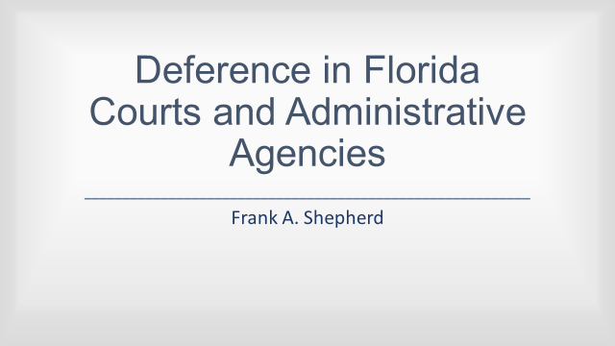**Chevron Deference in the Florida Courts and Administrative Agencies**

**Remarks by Frank A. Shepherd**

**Gray Robinson, P.A.**

Thank you for the opportunity to address this committee this afternoon.

I appear here this afternoon, respectfully, to speak about the use and, more importantly, misuse of judicial deference in the interpretation of laws passed by the legislature and rules promulgated by the administrative agencies, and in support of a proposed amendment to the Florida Constitution to remedy the misuse. The proposal reads as follows:

**SLIDE 2**

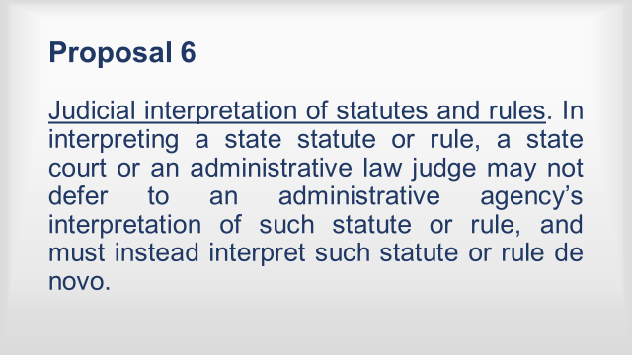

Judicial interpretation of statutes and rules. In interpreting a state statute or rule, a state court or an administrative law judge may not defer to an administrative agency’s interpretation of such statute or rule, and must instead interpret such statute or rule de novo.

I will confine my remarks largely to my own experiences, research and writings on the subject over more than a decade of service on the Third District Court of Appeal and, to some extent, my private practice prior thereto.

It is important at the outset to recognize that the question arises in not one, but rather two important arenas:

**SLIDE 3**

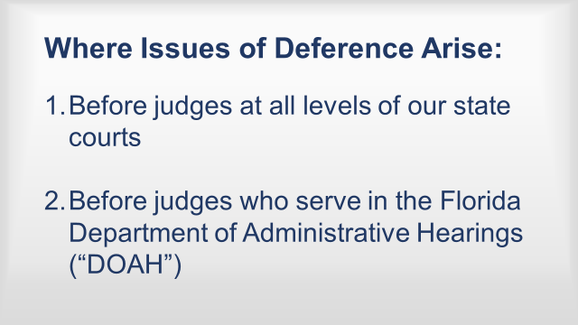

(1) Before judges at all levels of our state courts; and

(2) Before the judges, known as “administrative law judges, who serve in the Florida Department of Administrative Hearings (DOAH).

Although not a household word, this latter class of judges hears and adjudicates literally thousands of cases every year between a between the state or a county, municipality or independent agency and a citizen of the state, including, most prominently bid protests, post-bid contract disputes, state and local code violation disputes, public employee discipline cases, disability retirement cases and the like, where a state agency is a party.

**SLIDE 4**

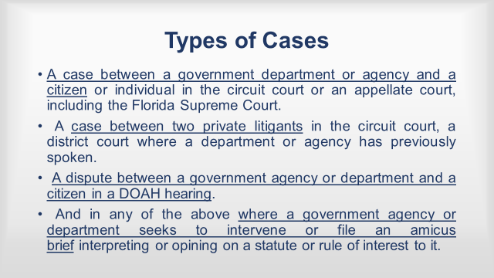

Thus, the problem of deference might appear, and often does appear, in:

A. A case between a government department or agency and a citizen or individual in the circuit court or an appellate court, including the Florida Supreme Court.

B. A case between two private litigants in the circuit court, a district court where a department or agency has previously spoken.

C. A dispute between a government agency or department and a citizen in a DOAH hearing.

D. And in any of the above where a government agency or department seeks to intervene or file an amicus brief interpreting or opining on a statute or rule of interest to it.

**SLIDE 5**



In any of these venues, the law as it presently exists gives an agency or department in the State of Florida – the Florida Department of Transportation, Florida Department of Health, Florida Department of Corrections, or Florida Department of Agriculture, and Florida Department of Business and Professional Regulation to name a few – near plenary authority to interpret the laws and rules they are charged to administer.

That authority is often expressed as follows in both judicial and administrative decisions:

**SLIDE 6**

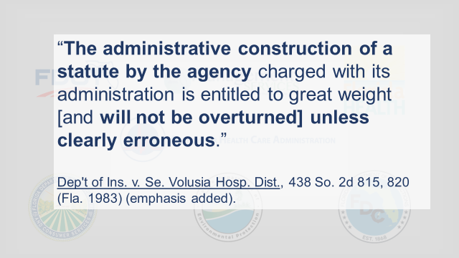

**An interpretation of a statute by an agency** charged with its administration is entitled to great weight and **will not be overturned unless it is clearly erroneous**.

Dep’t of Ins. v. Se. Volusia Hosp. Dist., 438, So. 2d 815, 820 (Fla. 1983); State ex rel. Biscayne Kennel Club v. Bd. of Bus. Regulation, Dept. of Bus. Reg., 276 So. 2d 823, 828 (Fla. 1973). This selection happens to be taken from an opinion of the Florida Supreme Court. However, the District Courts of Appeal, the state’s trial judges and administrative law judges are required to follow it.

**SLIDE 7**

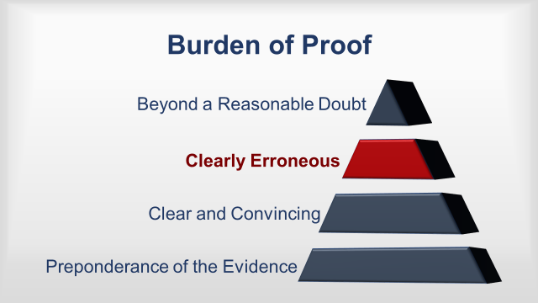

Importantly, the burden of proof that an agency interpretation is clearly erroneous rests on the individual or citizen challenging the interpretation. It is greater than the usual “preponderance of the evidence” standard. It is above the even more arduous “clear and convincing” standard – a standard a litigant must often satisfy to overturn judicial fact finding. It sits just below the “beyond a reasonable doubt” standard of evidence needed to convict a person of a crime.

**THE DUE PROCESS PROBLEM**

Perhaps even more profound, is the due process problem. It is not immediately apparent why a court should ever accept the judgment of an executive branch agency on a question of law.

Indeed, on its face the suggestion seems quite incompatible with Justice Marshall's aphorism, stated in Marbury v. Madison

**SLIDE 8**

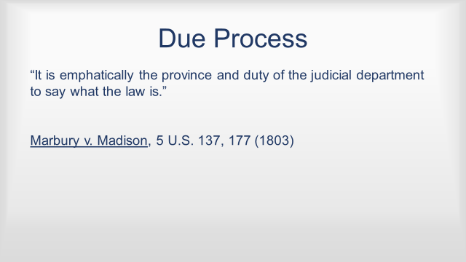

“[i]t is emphatically the province and duty of the judicial department to say what the law is.” See Marbury v. Madison, 5 U.S. (1 Cranch) 137, 177, 2 L.Ed. 60 (1803)[2].

As one percipient scholar has said:

**SLIDE 9**

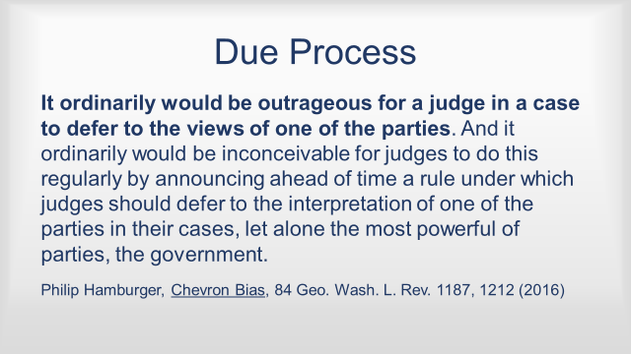

**It ordinarily would be outrageous for a judge in a case to defer to the views of one of the parties.** And it ordinarily would be inconceivable for judges to do this regularly by announcing ahead of time a rule under which judges should defer to the interpretation of one of the parties in their cases, let alone the most powerful of parties, the government. [Slide done. Just bold through the penultimate sentence.]

Philip Hamburger, Chevron Bias, 84 Geo. Wash. L. Rev. 1187 note 2 (2016). “Nonetheless,” as Professor Hamburger states, “this is what the judges have done” when a circuit judge, an appellate panel, the Florida Supreme Court or an administrative law judge gives deference to an agency interpretation of a statute or rule.

In short, judicial deference is inconsistent with the Due Process clause of the Florida Constitution. That clause states:

**SLIDE 10**

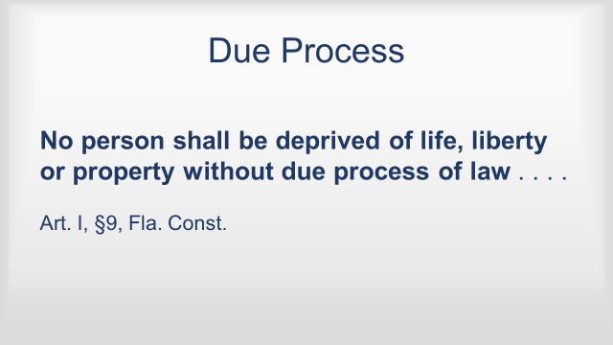

**No person shall be deprived of life, liberty or property without due process of law**, or be twice put in jeopardy for the same offense, or be compelled in any criminal matter to be a witness against oneself.

Art. I, §9, Fla. Const.

Judicial deference is also inconsistent with two provisions of the Florida Code of Judicial Conduct:

**SLIDE 11**

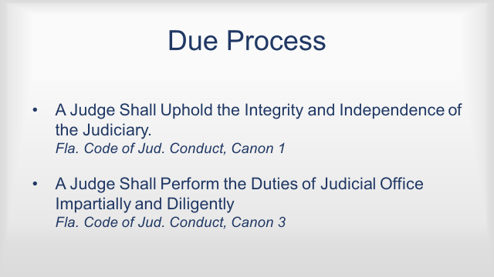

A. Canon 1: “A Judge Shall Uphold the Integrity and Independence of the Judiciary.”

B. Canon 3: “A Judge Shall Perform the Duties of Judicial Office Impartially and Diligently.”

The problem is perhaps no more clearly visible than in the administrative arena, which I mentioned earlier. A DOAH case is initiated by a state or local government agency when a party has the right to a hearing. A private party is on one side and a state or local government agency is on the other. The law governing administrative proceedings at DOAH are intended to help formulate agency action. So, the application of judicial deference in the administrative arena is doubly unfair under the due process clause because it puts the administrative law judge figuratively and almost literally in the pocket of the Agency whose case he or she is sworn to decide impartially.

You don’t need to take my word for it. A currently sitting Administrative Law Judge, Judge John Van Laningham, has made the point for all of us in a recently published opinion from his Court. As he described it:

**SLIDE 12**

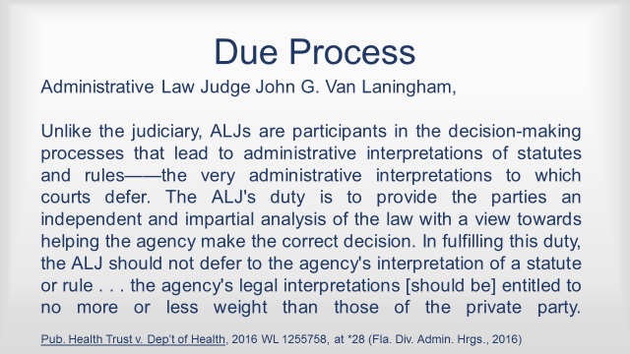

**Unlike the judiciary, ALJs are participants in the decision-making processes that lead to administrative interpretations of statutes and rules -- the very administrative interpretations to which courts defer.** **The ALJ's duty is to provide the parties an independent and impartial analysis of the law with a view towards helping the agency make the correct decision. In fulfilling this duty, the ALJ should not defer to the agency's interpretation of a statute or rule . . .**

**[T]he agency's legal interpretations [should be] entitled to no more or less weight than those of the private party.**

**SLIDE 13**

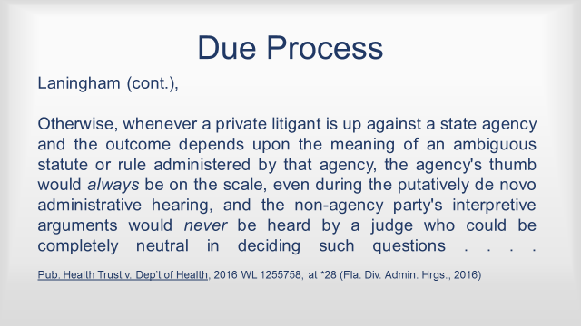

**Otherwise, whenever a private litigant is up against a state agency and the outcome depends upon the meaning of an ambiguous statute or rule administered by that agency, the agency's thumb would always be on the scale . . . and the non-agency party's interpretive arguments would never be heard by a judge who could be completely neutral in deciding such questions . . .**

The Public Health Trust of Miami-Dade County, Florida d/b/a Jackson South Community Hospital v. Department of Health and Kendall Healthcare Group, Ltd., d/b/a Kendall Regional medical Center**,** 2016 WL 1255758, at *28.

**SEPARATION OF POWERS**

Judicial Deference is also inconsistent with the separation of powers doctrine that has existed in our State Constitution without any substantial change since Florida became a state. It is a very robust provision. It states:

**SLIDE 14**

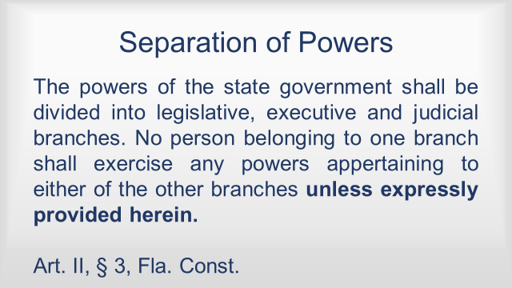

The powers of the state government shall be divided into legislative, executive and judicial branches. No person belonging to one branch shall exercise any powers appertaining to either of the other branches **unless expressly provided herein.**

Fla. Const. art. II, § 3.

Unlike Florida, the United States Constitution does not have an express separation of powers provision. And as I am sure this committee is aware, the rights set forth in our United States Constitution are considered a “floor,” below which no state may go in diminishing a citizen’s individual rights. However, states and even local governments may through their constitutions (or laws) provide their citizens greater protection of personal liberty or greater restrictions on governmental intrusion than afforded by the United States Constitution. The people of this state have regularly done so. Here are just two examples:

**SLIDE 15**

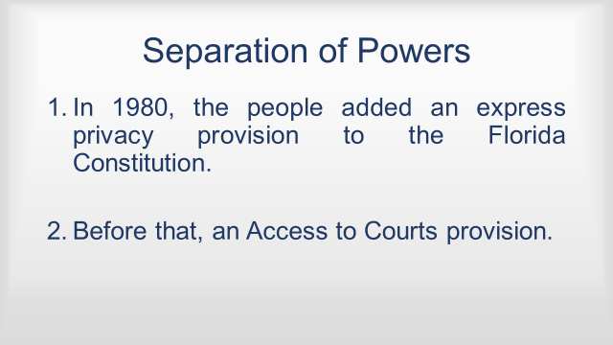

1. In 1980, the people added an express privacy provision to the Florida Constitution

2. Before that, an Access to Courts provision.

Addressing Article II, section 3, our Florida Supreme Court has stated:

**SLIDE 16**

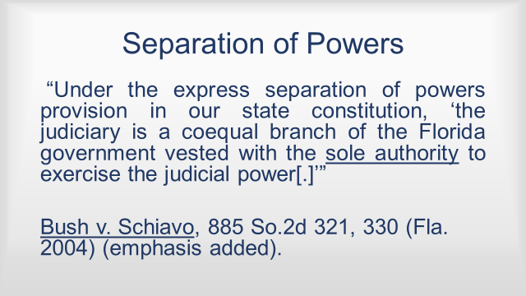

“Under the express separation of powers provision in our state constitution, ‘the judiciary is a coequal branch of the Florida government vested with the sole authority to exercise the judicial power [.]’”

See Bush v. Schiavo, 885 So.2d 321, 330 (Fla. 2004). Florida has had six constitutions since the formation of the state – 1838, 1861, 1865, 1868, 1885 and 1968. Each time, the people of this state have made clear they wanted a strict separation of powers among the branches of government. The adoption of the proposed amendment will reinforce Article II, section 3 by prohibiting judges from outsourcing interpretation of statutes and rules to agencies that have vested in them, or, in the case of rules, the agency that adopted the rule.

The doctrine of Separation of Powers is our most important legal tradition. The administrative state has mushroomed, especially in recent decades.

**CHEVRON**

Notice that I have not yet mentioned the *Chevron* Doctrine, the federal judicial counterpart to this state’s own judicially created deference doctrine. Because *Chevron* deference concerns federal administrative law, it does not control in the state courts of Florida. More importantly, the doctrine is not nearly as draconian in its breadth and application as is this state’s judicial creation. It applies only when:

**SLIDE 17**

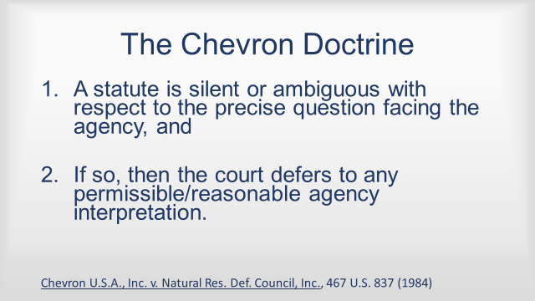

1. A statute is silent or ambiguous with respect to the precise question facing the agency, and

2. If so, then the court defers to any permissible/reasonable agency interpretation.

Chevron U.S.A., Inc. v. Natural Res. Def. Council, Inc., 467 U.S. 837 (1984).

In Florida, the agency’s interpretation is, for all practical purposes, controlling unless the citizen or individual challenging it can prove that the agency’s interpretation is “clearly erroneous.” As some of you, I am sure know, the Chevron Doctrine, which was adopted by the United States Supreme Court in 1984, has for some time been under heavy scrutiny. In fact, the most recently appointed Associate Justice of the United States Supreme Court, Neil Gorsuch, has openly said that the doctrine as it exists at the federal level should be re-examined.

**SLIDE 18**

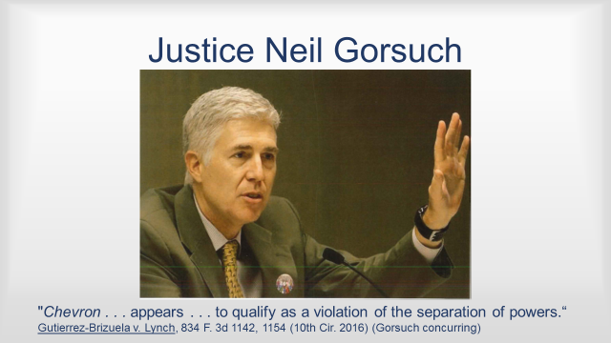

When I was on the Third District Court of Appeal I had a front row seat to see how the Florida judicially created deference rule was deployed in real time, if you will. The severity of the rule, reinforced by the onerous “clearly erroneous” threshold necessary for a citizen to overcome it, resulted in government departments and agencies exercising greater power than they should have been able to exercise. I wrote about the problem on several occasions. Here is one example:

**SLIDE 19**

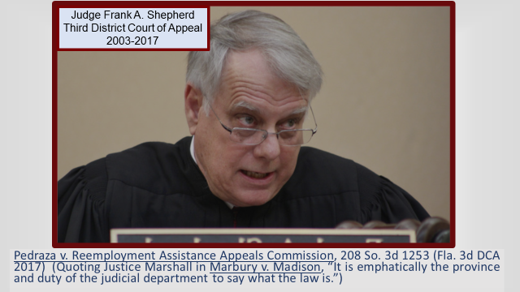

I concur in the result in this case. **I write only to rail once again, as I have on more than one prior occasion**—most recently, in Housing Opportunities Project, etc. et al, v. SPV Realty, LC, 212 419 (Fla. 3d DCA Dec. 21, 2016)—**that this Court should seriously consider the constitutional implications of blindly adhering to the mantra so regularly incanted by the Court to support, uphold, or approve agency decision-making that “an agency's interpretation of a statute, with which it is entitled with administering shall be accorded great weight and should not be overturned unless clearly erroneous, arbitrary, or unreasonable,” as well as the many variations on the theme.**

Pedraza v. Reemployment Assistance Appeals Comm'n, 208 So. 3d 1253, 1256–58 (Fla. Dist. Ct. App. 2017).

However, the Florida Supreme Court and inferior appellate courts seem content to allow unelected, unaccountable and unknown persons, however well-meaning, to say “what the law is” or should be. The rule of judicial deference to interpretations of statutes and rules by administrative agencies has become reflexively, if not mindlessly, invoked by many judges throughout the state. One can readily see how its application will become increasingly dangerous to individual liberty as the administrative state and its agencies continue to grow. That is why the subject has become a highly discussed topic on the federal level.

Finally, there should be no fear by any member of this Committee that by lending his or her support for Proposition 6 will somehow be upsetting long-standing precedent. The doctrine is not an ancient doctrine of judicial deference has come into its own only during the last quarter of the last century in Florida from about 1975 forward. The rule is incompatible with the important aphorism of perhaps the greatest Supreme Court Justice of all time:

“It is emphatically the province and duty of the judicial department to say what the law is. Marbury v. Madison, 5 U.S. (1 Cranch) 137, 177, 2 L.Ed. 60 (1803)[2].

I recommend the adoption of Proposal 6.

**SLIDE 20**

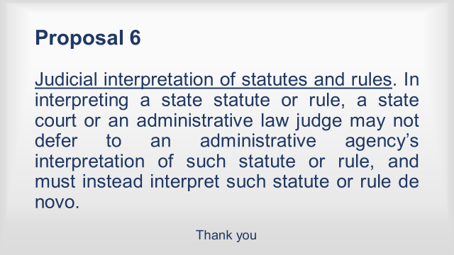

**The End**